**6E Process Calculations:** The 6E data is loaded into 22200 and 80300 accounts. But internally the data is loaded from different 7-digit accounts like 1152117, 1152120, 1152121, 1152116,1152118,1152119.

For 22200 account the data is loaded from the sum for 1152117, 1152120, 1152121 of External data is multiplied with the filters of FX rate numerator, current accounting period, GBP currency, FX Rate name SPOT, Rate Scenario Agresso.

For 80300 account the data is loaded from the multiplication of 22200 with -1.

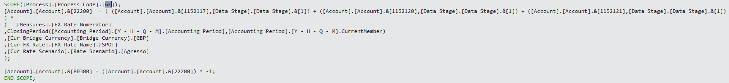

**1152116**: Sum the balances of 10100,30100,30500,10355,10200,30200,15100,35100,10265,15250,30125,35650 by using all process codes with Live Agresso data.

Include conditional checks based on the entity's current member value.

Divide the entire result by the following factors:

([Measures].[FX Rate Numerator],

ClosingPeriod([Accounting Period].[Y - H - Q - M].[Accounting Period],[Accounting Period].[Y - H - Q - M].CurrentMember),

[Cur Bridge Currency].[Bridge Currency].[GBP],

[Cur FX Rate].[FX Rate Name].[SPOT],

[Cur Rate Scenario].[Rate Scenario].[Agresso]

);

This division involves specific measures, accounting periods, currency information, and rate scenarios.

([Account].[Account].&[1152117]) = ([Account].[Account].&[1152116]) * ([Account].[Account].&[1152105])*-1

**1152117**: Assigning a value calculated by multiplying the balance of [Account].[Account].&[1152116] by the balance of [Account].[Account].&[1152105] and negating the result.

-( ( ([Account].[Account].&[20100],[Data Stage].[Data Stage].&[4],[Process].[Process Code].[All])

Subtract the sum of balances from accounts 20100,22100,20310,22710 of Live Agresso data is loaded with all process codes.

Divide the entire result by specific factors, similar to the previous division.

Complete the calculation and assign the result to the account with code [Account].[Account].&[1152117].

Divide the entire result by specific factors.

Complete the calculation and assign the result to the account with code [Account].[Account].&[1152117].

**1152118 & 1152120**: Repeating the similar calculations for the accounts with codes [Account].[Account].&[1152118] and [Account].[Account].&[1152120] within the same scope.

**1152119**: This assignment checks if the value of the account member with the key 1152117 is less than 0. If true, it assigns the value of 1152117 to the account member with the key 1152119; otherwise, it assigns NULL.

**1152120**: [Account].[Account].&[1152120], if the balance in one scenario is greater than the balance in another scenario:

IIF ( (([Account].[Account].&[1152119],[Cur Transaction Currency].[Tran Curr].[All]) * -1)

< ( ([Account].[Account].&[1152118],[Cur Transaction Currency].[Tran Curr].[All]) - ([Account].[Account].&[1152117],[Cur Transaction Currency].[Tran Curr].[All]) ),

If a specific condition involving balances is met, multiply the balance of the account with code [Account].[Account].&[1152119] by -1:

([Account].[Account].&[1152119]) * -1

Otherwise, if the condition is not met, calculate a ratio involving balances in different accounts:

DIVIDE( ( ([Account].[Account].&[1152118],[Cur Transaction Currency].[Tran Curr].[All]) - ([Account].[Account].&[1152117],[Cur Transaction Currency].[Tran Curr].[All]) )

* ([Account].[Account].&[1152119]),

([Account].[Account].&[1152119],[Cur Transaction Currency].[Tran Curr].[All])

)

If the condition in the second assignment's IF statement is true, use the result from the multiplication. If false, assign NULL to the account with code [Account].[Account].&[1152120]

**1152121**: Subtract the balance of the account with code [Account].[Account].&[1152117] and the balance of the account with code [Account].[Account].&[1152120] from the balance of the account with code [Account].[Account].&[1152118] using all currencies.

Multiply the result by the balance of the account with code [Account].[Account].&[1152116].

Divide the entire result by the balance of the account with code [Account].[Account].&[1152116] using all currencies.

Assign the calculated result to the account with code [Account].[Account].&[1152121].

**6G Process Calculations**: For 23401 account the data is loaded from the sum for 1152117, 1152120, 1152121 of External data is multiplied with the filters of FX rate numerator, current accounting period, GBP currency, FX Rate name SPOT, Rate Scenario Agresso.

For 23400 account the data is loaded from the multiplication of 23401 with -1.

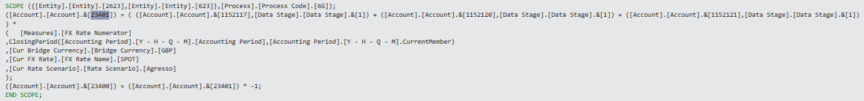

**1152116**: Sum the balances of two accounts 11101 & 16101 by using all process codes with Live Agresso data.

Divide the entire result by the following factors:

([Measures].[FX Rate Numerator],

ClosingPeriod([Accounting Period].[Y - H - Q - M].[Accounting Period],[Accounting Period].[Y - H - Q - M].CurrentMember),

[Cur Bridge Currency].[Bridge Currency].[GBP],

[Cur FX Rate].[FX Rate Name].[SPOT],

[Cur Rate Scenario].[Rate Scenario].[Agresso]

);

This division involves specific measures, accounting periods, currency information, and rate scenarios.

([Account].[Account].&[1152117]) = ([Account].[Account].&[1152116]) * ([Account].[Account].&[1152107])*-1

**1152117**: assign a value calculated by multiplying the balance of [Account].[Account].&[1152116] by the balance of [Account].[Account].&[1152107] and negating the result.

-( (

([Account].[Account].&[21102],[Data Stage].[Data Stage].&[4],[Process].[Process Code].[All])

+ ([Account].[Account].&[23101],[Data Stage].[Data Stage].&[4],[Process].[Process Code].[All])

)

Subtract the sum of balances from two accounts in the context of "All" currency in the "Cur Transaction Currency" dimension.

Divide the entire result by specific factors, similar to the previous division.

Complete the calculation and assign the result to the account with code [Account].[Account].&[1152117].

**1152118**: Repeat similar calculations for the accounts with codes [Account].[Account].&[1152118] within the same scope.

**1152119**: If the balance of the account with code [Account].[Account].&[1152117] is greater than 0, Otherwise, assign NULL.

([Account].[Account].&[1152120]) = IIF( ([Account].[Account].&[1152118],[Cur Transaction Currency].[Tran Curr].[All])

< ([Account].[Account].&[1152117],[Cur Transaction Currency].[Tran Curr].[All]),

For another account with code [Account].[Account].&[1152120], if the balance of the account with code ([Account].[Account].&[1152118],[Cur Transaction Currency].[Tran Curr].[All]) is less than the balance of the account with code ([Account].[Account].&[1152117],[Cur Transaction Currency].[Tran Curr].[All]), then do the following:

IIF ( (([Account].[Account].&[1152119],[Cur Transaction Currency].[Tran Curr].[All]) * -1)

> ( ([Account].[Account].&[1152118],[Cur Transaction Currency].[Tran Curr].[All]) - ([Account].[Account].&[1152117],[Cur Transaction Currency].[Tran Curr].[All]) ),

If a specific condition involving balances is met, then do this:

([Account].[Account].&[1152119]) * -1

Multiply the balance of the account with code [Account].[Account].&[1152119] by -1.

, DIVIDE( ( ([Account].[Account].&[1152118],[Cur Transaction Currency].[Tran Curr].[All]) - ([Account].[Account].&[1152117],[Cur Transaction Currency].[Tran Curr].[All]) )

* ([Account].[Account].&[1152119]),

([Account].[Account].&[1152119],[Cur Transaction Currency].[Tran Curr].[All])

)

If the condition is not met, calculate a ratio involving balances in different accounts.

, NULL

);

**1152120**: If the condition in the second assignment's IIF statement is false, assign NULL to the account with code [Account].[Account].&[1152120].

**1152121**: Subtract the balance of the account with code [Account].[Account].&[1152117] and the balance of the account with code [Account].[Account].&[1152120] from the balance of the account with code [Account].[Account].&[1152118] using all currencies.

Multiply the result by the balance of the account with code [Account].[Account].&[1152116].

Divide the entire result by the balance of the account with code [Account].[Account].&[1152116] using all currencies.

Assign the calculated result to the account with code [Account].[Account].&[1152121].